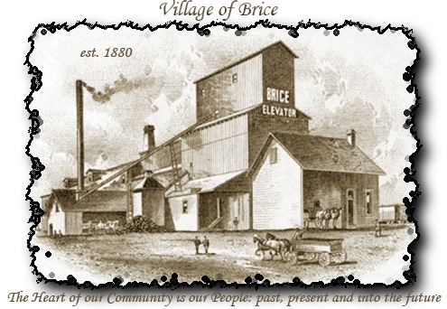
Fellowship Festival
May 20th – 21st, 2016
Vendor Application
Business Name:
Address:
 | Street |  |  |  |  |  |  |  | City |  |  |  |  |  | Zip code
Contact Person: |  |  |  |  |  |  |  |  |  | Phone Number:
Email:
Type of Vendor: |  | Informational |  | Craft/Merchant |  |  |  |  |  |  |  | Food
Details about the Items being sold or Information being given:
Requested Location:  (See Map for space numbers*) |  |  | 1st Location desired: |  |  |  |  |  |  |  | 2nd Location desired:
 |  | *All locations are first come- first served bases. Application must be approved and paid to reserve the location desired.
By signing this application, I have read and understand the rules. I agree to conform to the regulations set forth.
Signature |  |  |  |  |  |  |  | Date

